

Ward 8
Community Council Report

MID-FORMARTINE

BELHELVIE, TARVES, OLDMELDRUM AND UDNY

1 May – 31 May 2022

**In the event of a Police non-attendance at the meeting, can you ensure that you provide any concerns raised at the meeting to the Police ASAP by email to ensure we capture any issues early and can provide an update at the next meeting.**

This report covers progress we have made in dealing with your priorities for Ward 8 during the period 1 May – 31 May 2022. There will be no figures or comparison data provided in respect of the monthly overview.

The report aims to highlight emerging issues in your area, and to provide crime prevention advice and guidance to Community Council members and residents you represent. Our focus is to reduce crime and disorder, help create safer communities and respond effectively to local concerns.

Keeping people safe is at the heart of local Policing and our community based approach in Formartine continues to reduce crime and increase detection rates across the area.

The local priorities for Formartine are;
* Protecting Vulnerable People
* Serious and Organised Crime
* Anti-Social Behaviour, Violence and Disorder
* Road Safety and Road Crime
* Acquisitive Crime

Protecting Vulnerable People

Formartine officers remain, in many incidents, first responders to persons in crisis and provide an opportunity to really listen and get assistance to those in need. It is our aim to continue to work closely with key partner agencies to ensure the best and most suitable help is offered to persons in need.

Incidents involving mental health and suicide have a significant impact on close connections and the wider community and as such a list of sources is detailed in the Advice and Prevention Section of this report.

If there are any local organisations or facilities which currently offer a safe place or drop in facility for mental health or suicide, local Officers would be interested to hear from you and discuss options.

We continue to see isolated incidents of Domestic Abuse in Mid Formartine. This month there were no repeat victims of Domestic Abuse which provides some reassurance that measures Police Scotland and COPFS take to safeguard victims work.

Police Scotland and other agencies can provide confidential services in relation to Domestic Abuse and reports will be dealt with professionally and diligently. I would encourage those who are victim off or witness to incidents of domestic abuse, whether in the form of violence or coercive control, to report the matter to Police.

Serious and Organised Crime

We have not seen any incidents in Mid Formartine which have been linked to Serious and Organised Crime.

Even though there are no reports of this in Ward 8, please remain vigilant to issues and report any suspicious vehicles or behaviour to Police Scotland so we can investigate further.

Antisocial Behaviour, Violence and Disorder

Although information is received from other forums in relation to levels of Youth Annoyance, there is limited reporting from the community regarding Youth ASB. From the information, I am unable to confirm if this is due to under reporting or if there a minimal youth issues.

It is pleasing to report that there has been no instances of violence or disorder in the community.

Our Early Intervention Officer, Amanda Richardson, is looking to engage the local community, businesses and partners to organise activities across Formartine for young people to participate in. If you can offer time, funding or a safe space, or have any other ideas please contact Amanda via northeastearlyintervention@scotland.police.uk.

Road Safety and Road Crime

Formartine Policing Team and Officers from our Roads Policing Unit continue to actively monitor routes across Mid Formartine and conduct speed checks to educate and enforce road traffic legislation.

Speed checks are conducted in line with standard operating procedures and resources are deployed to areas which are greater risk and where action is required to be taken in the interest of casualty reduction.

We continue to receive reports in relation to Dangerous/Careless Driving, Driving under the influence of alcohol or controlled drugs, document offences, mud being deposited on the road and speeding.

Although there have been a number of Road Traffic Collisions across the area, these incidents did not result in serious injury and the biggest contributory factor was drivers not driving to the road and weather conditions presented.

The New Driver Scheme was introduced last month and more events will be hosted in the near future and it is aimed at those aged 17 to 25 years olds to promote safe driving and educated young/inexperienced drivers on the dangers of careless and inappropriate driving.

Road users should note that the Highway Code has been updated in relation to a number of areas with the introduction of The Hierarchy of Road Users. Further guidance can be found at

The Highway Code: 8 changes you need to know from 29 January 2022 - GOV.UK (www.gov.uk)

Acquisitive Crime

There have been very few acquisitive crimes reported within Ward 8 this month with the report of one theft and one fraud across the area.

There is not set demographic for who is targeted by the perpetrators and as such everyone should remain vigilant in respect of these incidents and report them to Police Scotland.

These incidents can originate in other parts of the world and it can take some time to identify who is responsible. Although there is international co-operation there are some restrictions which can hinder enquiries and bringing those responsible in front of a court.

As detailed in the SOCG section there has been an increase in other areas in relation to thefts in more rural areas.

I would encourage residents to take suitable preventative measures to protect their property from theft. For example removing the keys from vehicles and also not keeping them left in plain sight within the home. Secure sheds / outbuildings in which these vehicles and other property is kept as well as ensuring windows and doors are secured and locked. Installing effective security lighting and / or CCTV systems can also be a very effective deterrent.

Police Scotland has a dedicated Crime Reduction Unit who are specialised in this matter and are able to provide support and assistance to businesses as well as private residences in order to maximise security measures.

A wealth of information and advice relating to home security as well as other Police related matters can be accessed on the Police Scotland website at: https://www.scotland.police.uk/advice-and-information/

Special Constables

If you are interested in finding out more about what Police officers do in your community, have an interest in joining the regular service and would like to build some experience before hand or would just like to help keep your local community safe, then why not consider applying to be a Special Constable within Police Scotland.

For further information about becoming a Special Constable, what they do and how to apply, please visit: https://www.scotland.police.uk/recruitment/special-constables/

Advice and Prevention

Rural Watch

North East Scotland Rural Crime and Safety Partnership has been set up to specifically target matters affecting rural areas, including road safety, acquisitive crime, agricultural safety, live-stock worrying and hare-coursing.

In addition to this and after consultation with the national Neighbourhood Watch and the Scottish Partnership Against Rural Crime (SPARC), the Formartine Community Policing Team is keen to encourage local residents to sign up and use “Rural Watch Scotland”. You can register online by visiting: https://member-registration.neighbourhoodalert.co.uk/173/Join

Police Scotland regularly use this service as a means to convey various information about our local area. It has the benefit of being able to include more detailed information than is possible in a social media post, so it is really worthwhile signing up. Sign up is free and doesn’t take long.

Fraud Advice

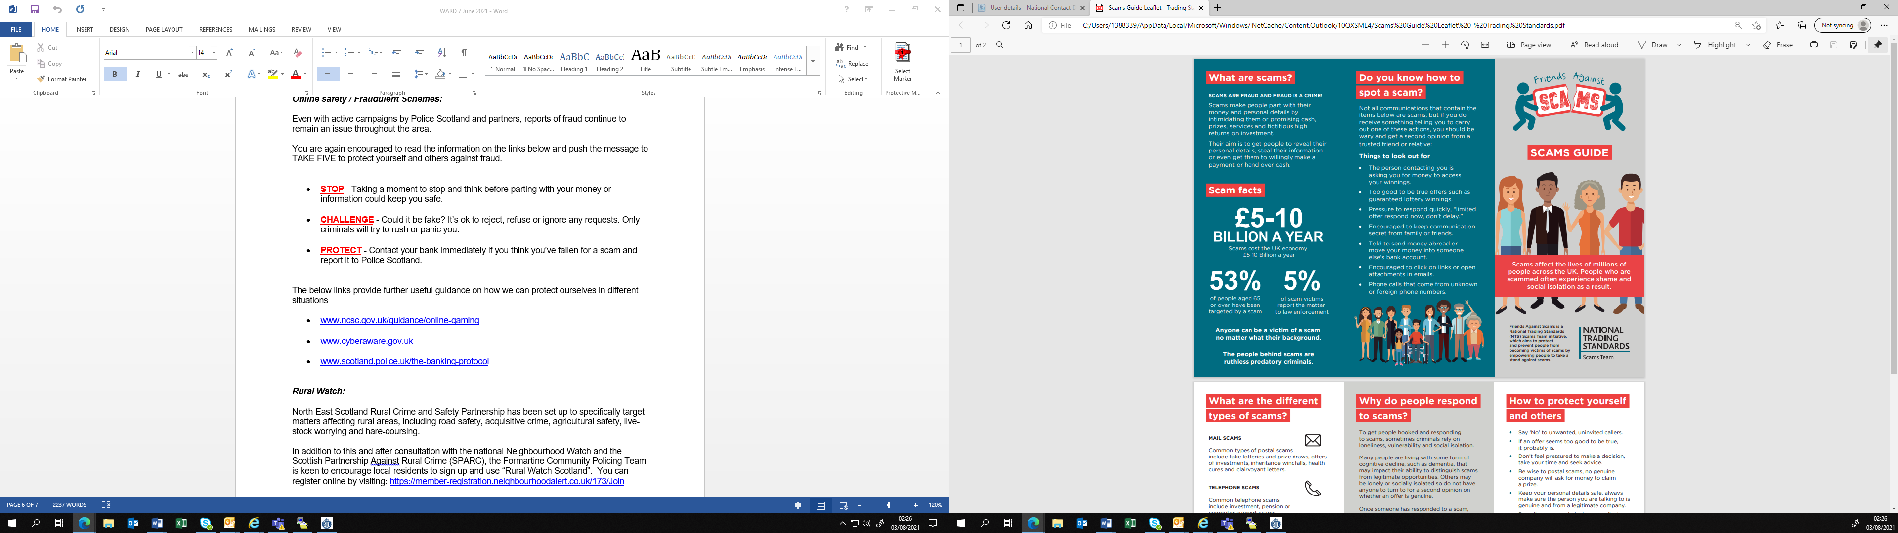
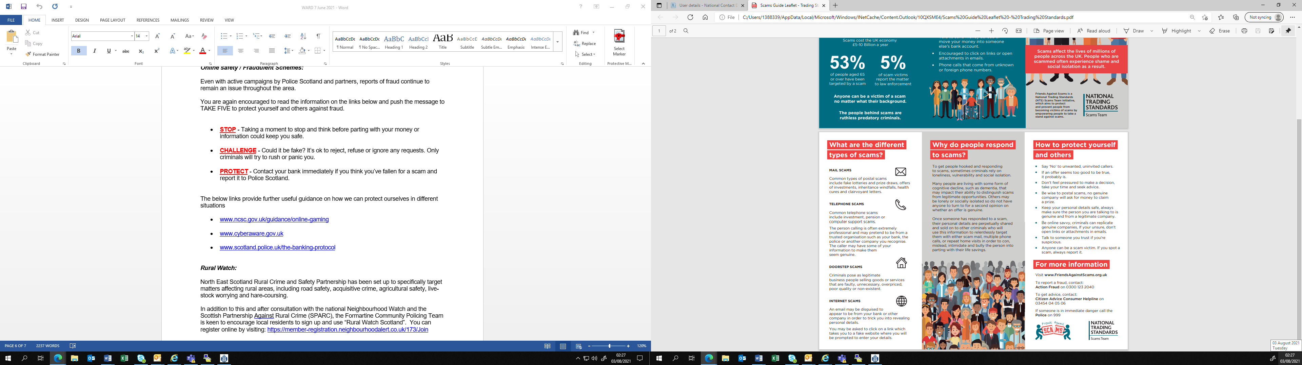

Mental Health and Suicide Awareness Contacts

Mind Infoline • 0300 123 3393 • info@mind.org.uk
Information on types of mental health problem, where to get help in your area, medication and alternative treatments, advocacy.

Mind Legal Line • 0300 466 6463 • legal@mind.org.uk
Legal advice on mental health, mental capacity, and community care human rights and discrimination/equality.

Victim Support • 0845 30 30 900 • www.victimsupport.org.uk
Free and confidential help to victims of crime, witnesses, and anyone else affected across England and Wales.

Samaritans • 08457 90 90 90 • www.samaritans.org
Support and advice for people experiencing a crisis.

Alzheimer’s Society • 020 7423 3500 • www.alzheimers.org.uk
Advice and information on supporting people affected by dementia in England, Wales and Northern Ireland.

Neighbourhood Return • www.ourturn.org.uk
Helps find lost people with memory problems quickly, and gets them home safely.

Self Help Services • www.selfhelpservices.org.uk
A user-led mental health charity providing primary care mental health services and self-help initiatives to people across the North.

NHS Choices • www.nhs.uk
Information on local services, including mental health services and emergency departments.

NHS24 Mental Health Hub • 111 • www.nhsdirect.nhs.uk
Information and advice on a wide range of health issues via telephone, email and the internet.

Local council websites • www.aberdeenshire.gov.uk
Will provide a directory of council services in your area.

Prevent Suicide NE App (available for free download on Android and iOS, info also available at https://www.preventsuicideapp.com/ ) – contains info on how to ask someone about their thoughts of suicide, a directory of local and national supports and an option to create a safe plan

Guidance booklets with further information are available through SAMH’s website (https://www.samh.org.uk/about-mental-health/samh-publications/suicide-publications)

