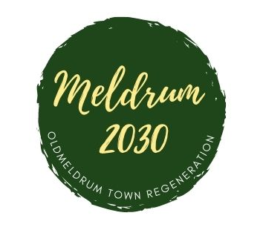

Meldrum 2030

Report to Community Council - February 2023

The group met recently to finalise the market dates for 2023

They are as follows

Wednesday 29th March - 9.30-12pm

Wednesday 28th June - 5-8pm

Wednesday 27th September- 9.30-12pm

Wednesday 29th November - 9.30-12pm

We still have spaces for food and drink stalls if anyone knows anyone who would like to attend please ask them to contact Jan Chalmers

Also the community stall and charity stall spaces are open for June-Nov so if anyone knows anyone who would like to attend in these spaces please let me know

