

Formartine Community Council Report

1 February – 28 February 2023

**In the event of a Police non-attendance at the meeting, can you ensure that you provide any concerns raised at the meeting to the Police ASAP by email to ensure we capture any issues early and can provide an update at the next meeting.**

This report covers progress we have made in dealing with your priorities for Formartine during the period 1 February – 28 February 2023. Although no figures or comparison data will be provided a light touch overview will be provided.

The report aims to highlight emerging issues in your area, and to provide crime prevention advice and guidance to Community Council members and residents you represent. Our focus is to reduce crime and disorder, help create safer communities and respond effectively to local concerns.

Keeping people safe is at the heart of local Policing and our community based approach in Formartine continues to reduce crime and increase detection rates across the area.

The local priorities for Formartine are;
* Protecting Vulnerable People
* Serious and Organised Crime
* Anti-Social Behaviour, Violence and Disorder
* Road Safety and Road Crime
* Acquisitive Crime

Protecting Vulnerable People

Formartine officers remain, in many instances, first responders to persons in crisis and provide an opportunity to really listen and get assistance to those in need. It is our aim to continue to work closely with key partner agencies to ensure the best and most suitable help is offered to persons in need.

We continue to see Officers in Formartine attending a number of calls in respect of residents across Formartine who have had concerns expressed for them or reported missing by family members, associates or other agencies who have advised the person has failed to engage with their services.

Some of the incidents have involved Officers attending to provide initial medical care, facilitating triage by Scottish Ambulance Service and in the most severe cases, transferring the person to hospital for care in the absence of an Ambulance.

The local Policing Team hold a list of Support Services available to residents of Aberdeenshire in respect of Mental Health and Wellbeing and will signpost to other services where appropriate.

Antisocial behaviour, Violence and Disorder

This priority encompasses a wide range of offences from lower level nuisance and disorder to more serious crimes of Assault and Robbery.

Calls relating to youth annoyance remain low across the area. Calls involving youths will continue to be monitored.

During February 2023, there has been several reports of assaults. These have either been detected or have positive lines of enquiry. These have happened in a licence premises and family settings. Licensed premises continue to engage with Officers during visits and incidents with Officers due to attend the next ‘Ellon Pub Watch’ meeting in March 2023. If other licensees across Formartine are interested in setting up a similar scheme please get in touch and we can provide guidance and contact information.

An individual was also quickly apprehended by members of the public and handed over to Police in relation to a Robbery in Ellon whereby a male stole several hundred pounds from an elderly man. Due to the swift actions of the public and officers in attendance, the money was recovered, the male responsible arrested and aftercare provided to the victim. This type of incident is not common in the area and appears to be isolated and opportunistic.

In this reporting period, there were also various Vandalisms reported. Most of these vandalisms have been detected and appears one individual has been responsible for a majority of them reported. The ones outstanding, appear to not be linked.

Police and partners continue to look to the Community for any suggestions in relation to diversionary activities which could be used for those on the periphery of criminality or to provide safe areas/activities for young persons to meet friends and hangout.

Our Early Intervention Officer, Amanda Richardson, is looking to engage the local community, businesses and partners to organise activities across Formartine for young people to participate in. If you can offer time, funding or a safe space, or have any other ideas please contact Amanda via northeastearlyintervention@scotland.police.uk.

Acquisitive Crime

Acquisitive crime encompasses a number of crimes such as Theft by Housebreaking, Vehicle Crime, Shoplifting, Fraud and Theft.

Reports of theft of fuel from rural areas are being reported across Police Scotland and some in the Formatine area. These crimes are usually carried out in rural areas to avoid being detected. The crimes occurred during the hours of darkness which makes it hard for the culprits to be detected/disturbed and also CCTV quality is also known to be poorer.

Whilst numbers for these crime types are low for the area, we continue to encourage member of the community to remain vigilant and report any suspicious behaviour/activity to Police Scotland as soon as possible, even it appears to be minor. Sometimes the additional information, however minor, may actually provide the missing piece in an on-going investigation and can prevent further incident from occurring.

It is important to emphasize the importance of working and well-maintained CCTV systems in order to apprehend offenders. Police Scotland has a dedicated Crime Reduction Unit who are specialised in this matter and are able to provide support and assistance to businesses as well as private residences in order to maximise security measures.

As indicated in previous reports, Fraud continues to have an upward trends with new scams being reported on a daily basis across the country.

Fraud types are as follows;

- Contact via WhatsApp pretending to be son/daughter requesting money for broken phone.
- Computer ‘Pop Ups’ advising computer is frozen or compromised and to call a specific number for repairs.
- Cryptocurrency Investment indicating they will pay off mortgages or double pension.
- Purchase of high value goods on Facebook Marketplace and eBay, deposit paid and item not existing/not delivered.
- Fake Currency in circulation.

Following instances of counterfeit currency being used to make purchases, Police Scotland are reminding retailers in the North East of the importance of checking all banknotes handed over as payment. Bank of England £20 and Bank of Ireland £50 notes appear to be the most common.
Visual checks can be made regarding the quality of both the paper/polymer and the print, check for good quality water marks. A poor quality foil strip can often be a giveaway as can the same serial number on the notes The use of detector pens will not work on the new polymer so ultra violet lamps should be used.
Advice leaflets are readily available from the various banks detailing the security features to look out for on each banknote.
If in doubt, compare the note to one that you know is genuine.

STOP – Taking a moment to stop and think before parting with your money or information
CHALLENGE – Could it be fake? It’s ok to reject/refuse or ignore any requests
PROTECT – Contact your bank immediately if you think you’ve fallen for a scam and report all scams to Action Fraud.

Police Scotland has a dedicated Crime Reduction Unit who are specialised in this matter and are able to provide support and assistance to businesses as well as private residences in order to maximise security measures.

A wealth of information and advice relating to home security as well as other Police related matters can be accessed on the Police Scotland website at: https://www.scotland.police.uk/advice-and-information/

Call 101 to report fraud or 999 in an emergency.

Where to Report Scams

Scams
In Scotland, report all scams to Advice Direct Scotland by calling 0808 164 6000 (Mon-Fri 9am-5pm) or online at www.consumeradvice.scot
Fraud
If you have been the victim of fraud, report it to Police Scotland on 101 or 999 in an emergency.
Suspicious Emails
You can forward suspicious emails to report@phishing.gov.uk and send links from websites which you think are trying to scam the public to the National Cyber Security Centre's scam website reporting service at www.ncsc.gov.uk/section/about-this-website/report-scam-website
Suspicious Text Messages
If you receive a suspicious text message you can forward it to 7726. The free-of-charge ‘7726’ service enables your provider to investigate and take action if malicious content is found.

Road Safety & Road Crime

Safety on our roads remains a priority within the Formartine area. Officers have been engaging in roadside speed checks and offending drivers being dealt with in accordance with guidance relevant to the speeds detected. The speed detection sign has continued to be deployed across the region as a positive reminder to drivers of their speed and the speed limit to which they are in. In addition to this, our colleagues in the Roads Policing department, as well as the safety camera unit are continuing in their efforts to educate and enforce on our roads.

We are continuing in our actions to tackle antisocial driving across the region with a number of drivers being dealt with in relation to motoring offences including noisy exhausts and speeding. We will continue to patrol hotspots and carry out follow up enquiries on any reports of antisocial driving received in an effort to gain sufficient evidence to charge those responsible for antisocial driving.

In February 2023 we welcomed our 3 Pop-up Bobbies” who have now been deployed across the region. They are life sized signs that carry the appearance of a police officer and are placed at various locations at the roadside to remind drivers to drive responsibly.

The locations of the “pop-up bobbies” will change regularly to ensure road users do not become accustom to them and remember that it could possibly be a Police Officer just around the corner.

As we remain within the winter period with reduced temperatures due over the next few days/week, motorists are reminded of the importance of driving to the conditions and taking the time to ensure their vehicle is safe to drive prior to departure. As per the Highway Code failure to have a full view of the road and traffic is an offence as such please ensure the cars full windscreen is cleared of all frost/snow/condensation.

We continue to actively monitor routes across our area and conduct speed checks to educate and enforce road traffic legislation. The variable speed detection sign has been deployed across the region this month which has been a positive reminder to drivers of their speed.

In January, there were over 92 occasions where Police have been contacted in relation Road Traffic matters, which range from road accidents, assist members of the public or other vehicle enquiries.

A Road Traffic initiative has been run over the past month throughout the Formartine area. This is to remind drivers not only of their speeds but also manner of driving.

Tickets, warnings and advice have been given to motorists and will continue to be monitored in the following months.

We are appreciative of the work being performed by Colin Anderson in relation to Community Speed Watch which appears to be gathering momentum.

Serious & Organised Crime

Officers in Formartine have been proactive in their approach in relation to Serious and organised crime with a number of persons being stopped by Officers and searched using Police powers to search for Possession of Controlled Drugs and Offensive Weapons with a number of seizures of both.

An individual has been charged in relation to the production of a controlled drug. This individual will be reported to the Procurator Fiscal.

We would as residents to remain vigilant to issues and report any suspicious vehicles or behaviour to Police Scotland so we can ‘Ditch the Dealer’ and put a stop to the untold misery drugs cause to individuals, families and communities as a whole. The below form can be used to see what information is helpful to your Community Policing Team.

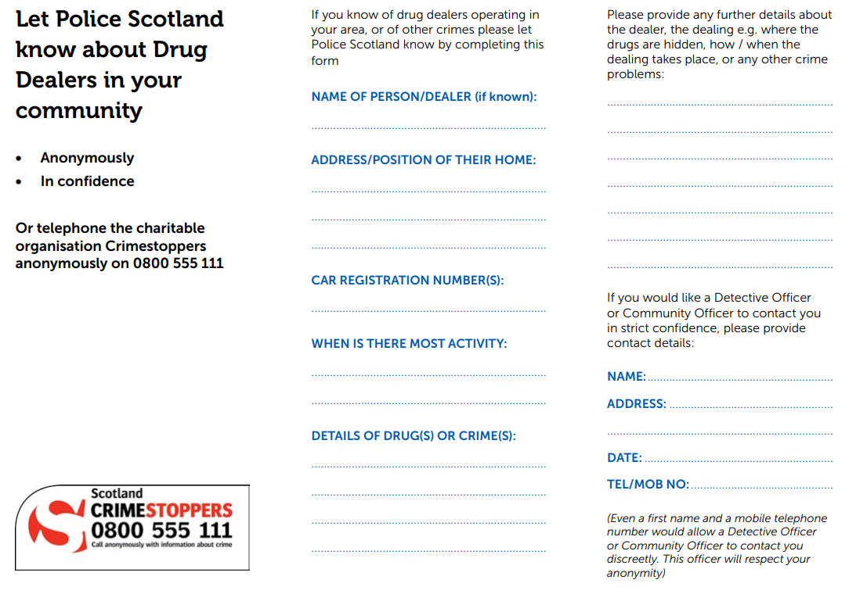

Crime Prevention

Darker Nights

At home

Keep front and back doors locked at all times and keep keys and valuables out of sight and reach from cat flaps, letterboxes and downstairs doors and windows.

Close, and ideally lock, all windows when you are not in – approximately one in four break ins still happen because doors have been left unlocked or windows left open

If it's dark before you get home, use timer switches to turn on the lights – change the times that the lights come on, to create the illusion that someone is moving around inside the house. Plug-in dusk-to-dawn lights are also popular and economical to use.

Make sure your door is well lit and fully visible from the street – dusk-to-dawn lamp adaptors are available from DIY stores and again are cost effective.

Check existing lighting is in good working order and replace any faulty equipment – remember to check batteries in torches and smoke alarms

Keep shrubbery and hedges at the front of the house pruned to below one metre – remove any cover for a criminal to work unseen and give your neighbours every chance to spot something suspicious

Keep curtains closed at night – if you are away, ask a trusted neighbour to close them for you, and open them again in the morning.

Assess your property's perimeter and check it is secure. Cut back overgrown hedges and repair broken fences and gates

Secure sheds and outbuildings with good padlocks and consider fitting alarms. Lock all tools and ladders away securely

On cold mornings, never leave your car unattended with the engine running to defrost the windows

When out and about

When out in your car, look out for the safe Park Mark accredited car parks and remove all items from your vehicle when you leave it

Don't leave your keys in the ignitions, even when filling up with fuel or popping into the shop

Plan ahead before you go out. Know where you are going, how you'll get there, and how you'll get back. Let someone know where you are going, and be prepared for a change of plan.

When you are out walking keep to well-lit, busy areas, using the route you know best.

Don't be tempted to take short cuts that require you to stray from busy areas.

Avoid quiet or badly-lit alleyways, subways or isolated car parks.

Remain aware of your surroundings – do not walk along texting, making a phone call or listening to music. These will distract you.

Keep valuables out of sight.

If you regularly walk home in the dark, get a personal attack alarm approved by Sold Secure - they are widely available and inexpensive

Wear reflective clothing - this allows cyclists and cars to see you as you walk along, especially in low visibility areas. A flashlight or headlight can also help drivers see you if there are dark stretches of road on your route.

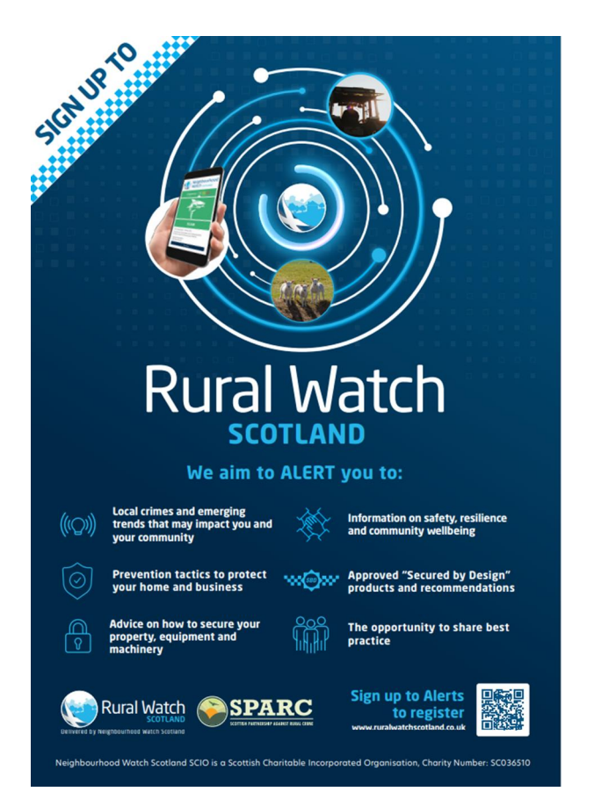

Mental Health and Suicide Awareness Contacts

Mind Infoline • 0300 123 3393 • info@mind.org.uk
Information on types of mental health problem, where to get help in your area, medication and alternative treatments, advocacy.

Mind Legal Line • 0300 466 6463 • legal@mind.org.uk
Legal advice on mental health, mental capacity, and community care human rights and discrimination/equality.

Victim Support • 0845 30 30 900 • www.victimsupport.org.uk
Free and confidential help to victims of crime, witnesses, and anyone else affected across England and Wales.

Samaritans • 08457 90 90 90 • www.samaritans.org
Support and advice for people experiencing a crisis.

Alzheimer’s Society • 020 7423 3500 • www.alzheimers.org.uk
Advice and information on supporting people affected by dementia in England, Wales and Northern Ireland.

Neighbourhood Return • www.ourturn.org.uk
Helps find lost people with memory problems quickly, and gets them home safely.

Self Help Services • www.selfhelpservices.org.uk
A user-led mental health charity providing primary care mental health services and self-help initiatives to people across the North.

NHS Choices • www.nhs.uk
Information on local services, including mental health services and emergency departments.

NHS24 Mental Health Hub • 111 • www.nhsdirect.nhs.uk
Information and advice on a wide range of health issues via telephone, email and the internet.

Local council websites • www.aberdeenshire.gov.uk
Will provide a directory of council services in your area.

Prevent Suicide NE App (available for free download on Android and iOS, info also available at https://www.preventsuicideapp.com/ ) – contains info on how to ask someone about their thoughts of suicide, a directory of local and national supports and an option to create a safe plan

Guidance booklets with further information are available through SAMH’s website (https://www.samh.org.uk/about-mental-health/samh-publications/suicide-publications)

