

Formartine Community Council Report

1 April – 30 April 2023

**In the event of a Police non-attendance at the meeting, can you ensure that you provide any concerns raised at the meeting to the Police ASAP by email to ensure we capture any issues early and can provide an update at the next meeting.**

This report covers progress we have made in dealing with your priorities for Formartine during the period 1 April – 30 April 2023. Although no figures or comparison data will be provided a light touch overview will be provided.

The report aims to highlight emerging issues in your area, and to provide crime prevention advice and guidance to Community Council members and residents you represent. Our focus is to reduce crime and disorder, help create safer communities and respond effectively to local concerns.

Keeping people safe is at the heart of local Policing and our community based approach in Formartine continues to reduce crime and increase detection rates across the area.

The local priorities for Formartine are;
* Protecting Vulnerable People
* Serious and Organised Crime
* Anti-Social Behaviour, Violence and Disorder
* Road Safety and Road Crime
* Acquisitive Crime

As per the information provided in the March report, we are continuing to make efforts to attend community council meetings on a two month rota. We managed to attend all five meetings planned in April and are now looking ahead to May where we hope to attend Foveran, Belhelvie, Meldrum, Fyvie and Turriff. Can you please make sure to advise us of dates, times and locations of the meetings in advance by emailing;

MidFormartineCPT@Scotland.police.uk
EllonDistrictCPT@Scotland.pnn.police.uk
TurriffDistrictCPT@Scotland.police.uk

Protecting Vulnerable People

Formartine officers remain, in many instances, first responders to persons in crisis and provide an opportunity to really listen and get assistance to those in need. It is our aim to continue to work closely with key partner agencies to ensure the best and most suitable help is offered to persons in need.

We still receive a large amount of calls in the Formartine area that relate to a concern being raised for local residents. This concern can manifest in many ways, ranging from a report of a missing person, mental health episodes or other agencies advising that a person has failed to engage with their services.

Officers are required to attend these calls in the first instance and make enquiries. This can often lead to officers being engaged in these enquiries for a substantial period, particularly in the case of missing persons. We also provide initial medical care in advance of attendance of the Scottish Ambulance Service and, in the most severe cases, may have to transfer a person to hospital for care in the absence of an Ambulance.

The local Policing Team hold a list of Support Services available to residents of Aberdeenshire in respect of Mental Health and Wellbeing and will signpost to other services where appropriate.

Antisocial behaviour, Violence and Disorder

This priority encompasses a wide range of offences from lower level nuisance and disorder to more serious crimes of Assault and Robbery.

Due to the nights becoming longer and lighter, it is anticipated that there will be more youths out and about. Youths in numbers can be understandably intimidating but not an offence.

There was a number of youth calls during the Easter holidays which has resulted in some criminality. These youths have been charged with the relevant offences and reports have been submitted to the relevant agencies.

During April 2023, there has been several reports of violence across the area. These have either been detected or have positive lines of enquiry. Overall, incidents of violence reported remain low across the area.

Police and partners continue to look to the Community for any suggestions in relation to diversionary activities which could be used for those on the periphery of criminality or to provide safe areas/activities for young persons to meet friends and hangout.

Our Early Intervention Officer, Amanda Richardson, is looking to engage the local community, businesses and partners to organise activities across Formartine for young people to participate in. If you can offer time, funding or a safe space, or have any other ideas please contact Amanda via northeastearlyintervention@scotland.police.uk.

Acquisitive Crime

Acquisitive crime encompasses a number of crimes such as Theft by Housebreaking, Vehicle Crime, Shoplifting, Fraud and Theft.

Theft by Housebreaking’s have occurred this month across the division. It appears outbuildings are the main target. We have also seen a number of thefts in relation to quad bike vehicles being taken from rural properties.

We would encourage members of the community to ensure that you consider the security of your own property, ensuring doors and windows are locked and that items of value are kept out of plain sight. We would also like to remind the community to remain vigilant and to report anything suspicious to Police Scotland as soon as possible. Even if you think it may seem irrelevant, the information you provide could be vital to an ongoing investigation and assist us in bringing perpetrators to justice.

A working and well-maintained CCTV system can act as strong deterrent to criminals, as well as providing vital evidence when incidents do occur. There is a wide availability now of video doorbells and camera systems that can be linked to a mobile phone that can provide notification when sensing motion. If you have any questions around CCTV systems or indeed any factor in relation to security, the Police Scotland Crime Reduction Unit are specialised in this matter and are able to provide support and assistance to businesses as well as private residences.

Fraud continues to feature regularly in the reports we receive, with new scams being reported on a daily basis across the country.

Common Fraud types are as follows;

- Contact via WhatsApp pretending to be son/daughter requesting money for broken phone.
- Computer ‘Pop Ups’ advising computer is frozen or compromised and to call a specific number for repairs.
- Cryptocurrency Investment indicating they will pay off mortgages or double pension.
- Purchase of high value goods on Facebook Marketplace and eBay, deposit paid and item not existing/not delivered.
- Fake Currency in circulation.

A wealth of information and advice relating to home security as well as other Police related matters can be accessed on the Police Scotland website at: https://www.scotland.police.uk/advice-and-information/

Call 101 to report fraud or 999 in an emergency.

Where to Report Scams

Scams
In Scotland, report all scams to Advice Direct Scotland by calling 0808 164 6000 (Mon-Fri 9am-5pm) or online at www.consumeradvice.scot
Fraud
If you have been the victim of fraud, report it to Police Scotland on 101 or 999 in an emergency.
Suspicious Emails
You can forward suspicious emails to report@phishing.gov.uk and send links from websites which you think are trying to scam the public to the National Cyber Security Centre's scam website reporting service at www.ncsc.gov.uk/section/about-this-website/report-scam-website
Suspicious Text Messages
If you receive a suspicious text message you can forward it to 7726. The free-of-charge ‘7726’ service enables your provider to investigate and take action if malicious content is found.

Road Safety & Road Crime

Safety on our roads remains a priority within the Formartine area and officers have been dispatched to various locations throughout the area to carry out roadside speed checks. Any driver detected as driving over the speed limit is stopped and dealt with by means of a warning, ticket or reported to the courts based on national guidance.

The speed detection sign continues to be deployed across the region as a positive reminder to drivers of their speed and the limit to which they are in. Please note that this can only be deployed in areas governed by a 20 or 30 miles per hour speed limit due to the abilities of the device. We have received positive feedback in relation to the impact that this device has had in areas of its deployment.

In addition to the above, our colleagues in the Roads Policing Unit, as well as the safety camera unit, are continuing to have a strong presence on the road networks running through our area. We are all working together to make sure that our roads are safer and that any drivers failing to obey the rules are dealt with robustly.

Our efforts are ongoing in relation to tackling antisocial driving across the region with Police units being deployed to local “hot spots” when we are able. A number of offences have been detected over the last month, including speeding, noise related offences and vehicle condition. These have been dealt with in a number of ways, including use of Antisocial Behaviour legislation that allows us to place a warning marker against both a vehicle and person when antisocial driving is detected. This allows us to deal with any further incidents detected in relation to either the vehicle or person by seizing the vehicle they are in. This marker lasts for 12 months and is a useful tool in our ongoing efforts.

We would encourage members of the local community to report any instances of antisocial driving to Police Scotland via 101 or the online “Contact Us” form. Ongoing incidents and resource levels may mean that we are unable to attend immediately but will make follow up enquiry when we can. Information that will assist us in these enquiries is vehicle registration, colour, make and model of vehicle, any description you can pass of the driver or name if they are known to you, specific time that incident has occurred.

In April, we have attended a number of reports in relation to Road Traffic matters, which range from road accidents, assisting members of the public or other vehicle enquiries. As we approach the Summer months, we are likely to see an increase in motorcycles on our roads. Motorcycles are often less noticeable on the road due to their smaller size, which can lead to accidents. We would like to remind local road users to take that extra bit of time to think bike and pay extra attention at junctions.

Serious & Organised Crime

Officers in Formartine continue to work proactively in their approach to serious and organised crime with a number of persons being stopped and searched utilising appropriate Police powers. These powers allow us to search for a variety of items including controlled drugs, offensive weapons and stolen property. These powers are not used lightly and require a “reasonable cause” to suspect that a person is in possession of said items. This information often comes from the local community.

We would advise residents to remain vigilant to issues and report any suspicious vehicles or behaviour to Police Scotland so we can ‘Ditch the Dealer’ and put a stop to the untold misery drugs cause to individuals, families and communities as a whole. The sort of behaviour that may be relevant could be, but is not limited to, as strong, often herbal, smell coming from a property, a number of different people or vehicle attending a property at all times of the day and night, items being exchanged through a letterbox or window.

The below form can be used to see what information is helpful to your Community Policing Team.

A sizeable cannabis cultivation was discovered in the area this month. This was discovered by officers being proactive and stopping to speak with a male whom was acting suspiciously in the area. Enquiries are on-going into this at the time of writing.

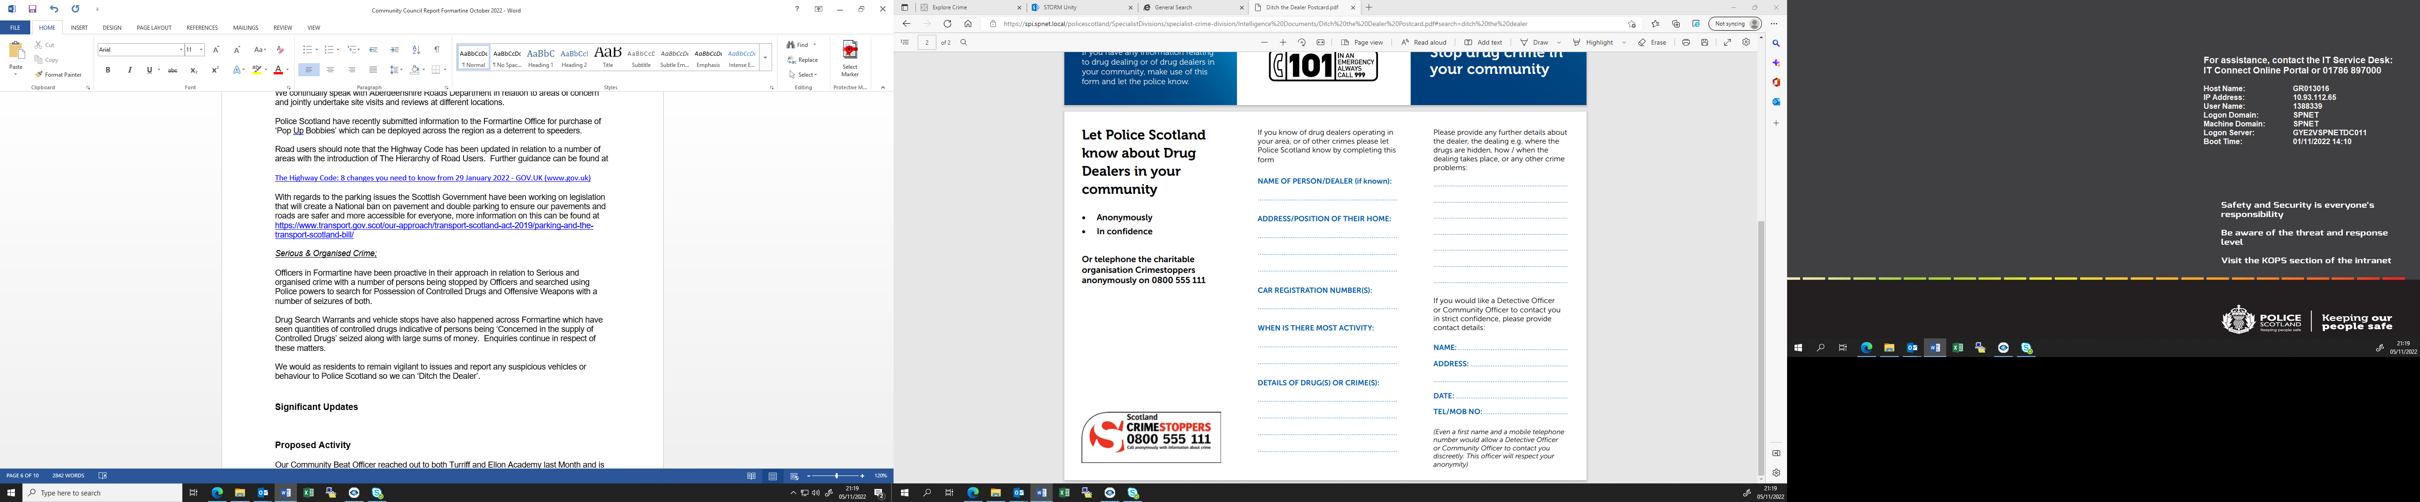

Crime Prevention


North East Division Crime Reduction Officer Constable Irvine said ‘Always use two good quality locks, at least one of which is a D-lock, to secure your bike even when stored inside a garage. As a ‘rule of thumb’ look to spend at least 10% of the value of the bike on security. Secure your bike to the fabric of the garage or shed using a ground anchor and heavy chain and ALWAYS lock the door.
Photograph your bike and record all of your bike’s details and distinguishing features and keep in a safe place. The serial number can be found on the bottom bracket. Consider using a bike registration scheme such as ‘Bike Register’ to mark your bicycle. Not only is this a deterrent to thieves but should you be unlucky enough to have your bicycle stolen it increases the chances of getting your bicycle back.
Always buy the best quality lock you can afford and look out for those that have been endorsed as ‘Sold Secure’ or ‘Secured by Design.’
Details of how to secure your bikes can be found at –
www.securityforbikes.com

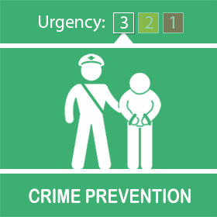

Following a recent report of potential rogue traders operating in the area, we encourage people to remain vigilant.
An elderly homeowner was approached at the door by a male offering to clear the guttering. The family of the householder were alerted to the male via a video doorbell, and no work was subsequently carried out. The tradesman's intentions may not have been criminal but highlights the need to be on your guard to cold callers.
North East Division Crime Reduction Officer PC Russell said; 'Beware of any company cold-call, offering to make repairs or work on your house, garden or driveway. In reality, they charge inflated prices for shoddy or completely unnecessary work. We do not recommend dealing with cold callers for property maintenance or repairs to your home & garden. "Be on your guard if someone turns up unexpectedly. Ask yourself if your premises or garden does require work to be carried out & remember, if it sounds too good to be true, it probably is. Look out for vulnerable neighbours and family members who may fall foul of these criminals. Don’t feel pressurised into agreeing immediately to work being carried out & never pay cash upfront. Should you require work to be carried out, always get quotes from reputable companies.'

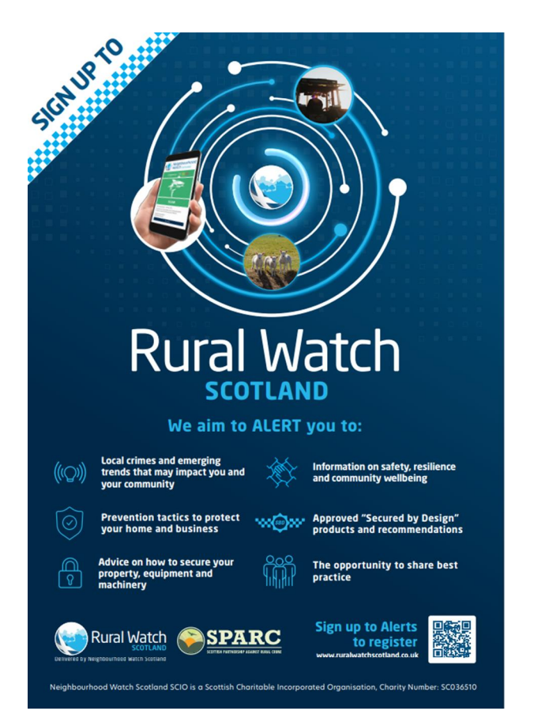

Crimes In Your Area

Belhelvie
No incidents of note to report.
Slains and Collieston
No incidents of note to report.
Foveran
No incidents of note to report.
Fyvie, Rothienorman, Monquhitter
Theft of a Quad Bike. Enquiries are ongoing.
Meldrum, Daviot and Bourtie
No incidents of note to report.
Methlick
No incidents of note to report.
Tarves
Theft of a Quad Bike from a rural property. Enquiries are at an early stage with some positive lines to follow.
Turriff and District
Theft of a power washer trailer combo from a rural property. Enquiries are ongoing.
Udny
No incidents of note to report.
Ythan/Ellon
Assault and Robbery – Within a domestic dwelling, no wider threat to the public, individual arrested and put to court the next working day.
Wilful fire-raising in the grounds of Ellon Academy. Very minor damage caused to a perimeter fence. Enquiries ongoing to identify the person(s) responsible.

Mental Health and Suicide Awareness Contacts

Mind Infoline • 0300 123 3393 • info@mind.org.uk
Information on types of mental health problem, where to get help in your area, medication and alternative treatments, advocacy.

Mind Legal Line • 0300 466 6463 • legal@mind.org.uk
Legal advice on mental health, mental capacity, and community care human rights and discrimination/equality.

Victim Support • 0845 30 30 900 • www.victimsupport.org.uk
Free and confidential help to victims of crime, witnesses, and anyone else affected across England and Wales.

Samaritans • 08457 90 90 90 • www.samaritans.org
Support and advice for people experiencing a crisis.

Alzheimer’s Society • 020 7423 3500 • www.alzheimers.org.uk
Advice and information on supporting people affected by dementia in England, Wales and Northern Ireland.

Neighbourhood Return • www.ourturn.org.uk
Helps find lost people with memory problems quickly, and gets them home safely.

Self Help Services • www.selfhelpservices.org.uk
A user-led mental health charity providing primary care mental health services and self-help initiatives to people across the North.

NHS Choices • www.nhs.uk
Information on local services, including mental health services and emergency departments.

NHS24 Mental Health Hub • 111 • www.nhsdirect.nhs.uk
Information and advice on a wide range of health issues via telephone, email and the internet.

Local council websites • www.aberdeenshire.gov.uk
Will provide a directory of council services in your area.

Prevent Suicide NE App (available for free download on Android and iOS, info also available at https://www.preventsuicideapp.com/ ) – contains info on how to ask someone about their thoughts of suicide, a directory of local and national supports and an option to create a safe plan

Guidance booklets with further information are available through SAMH’s website (https://www.samh.org.uk/about-mental-health/samh-publications/suicide-publications)

